Assignment 1B

Anmol Sharma

Georgian College

Mobile and Pervasive Computing

Prof. Jaret Wright

Sunday, October 03, 2021

1. **Submit an initial list of required database collections.**

**Answer: -**

** User Information (firstName, lastName, userId, password)

** Listing Information (sellerPhone, propertyAddress, propertyPrice)

1. **Using any design / mockup tool of your choosing, create a mockup for each activity in your app (at least 3). The app design should follow Google’s Material Design guidelines. Compile the set of mockups into ONE design document in PDF format.**

**Answer: -**

** Sign up

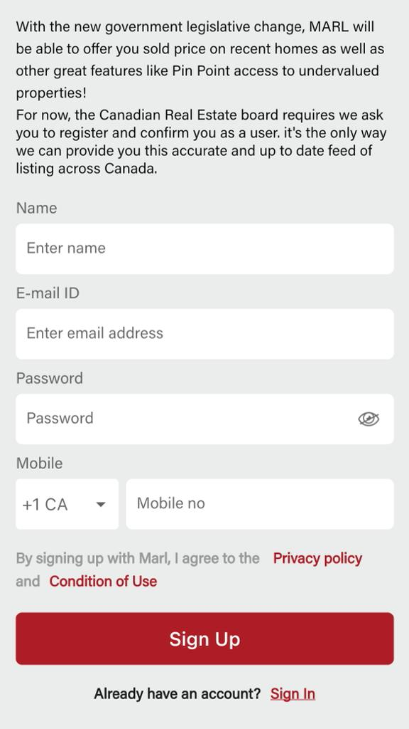

** Log in

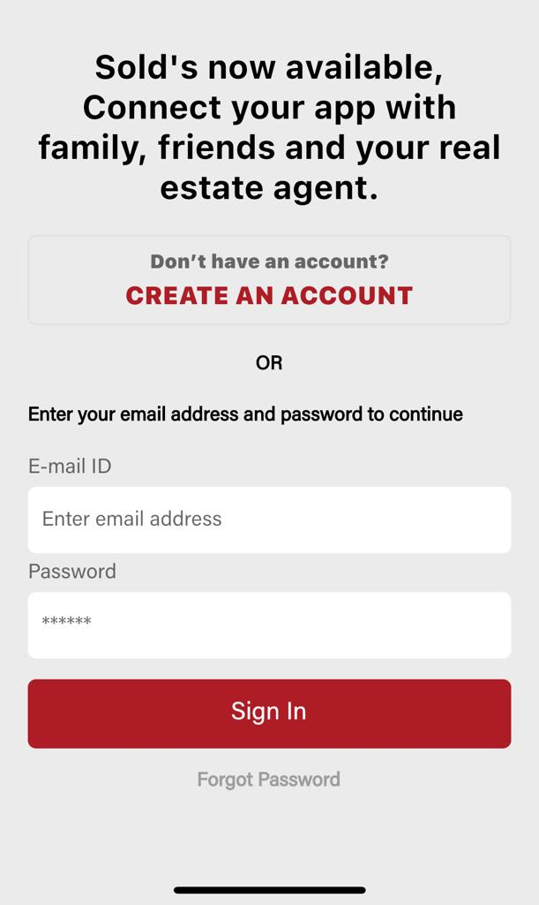

** Property listings

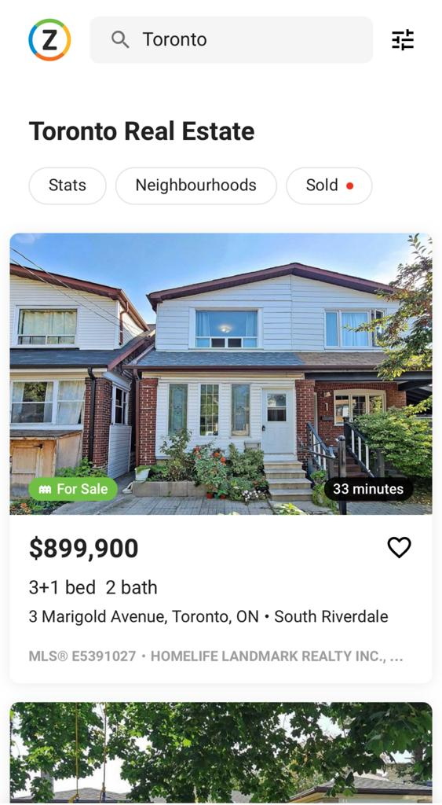

** Property description

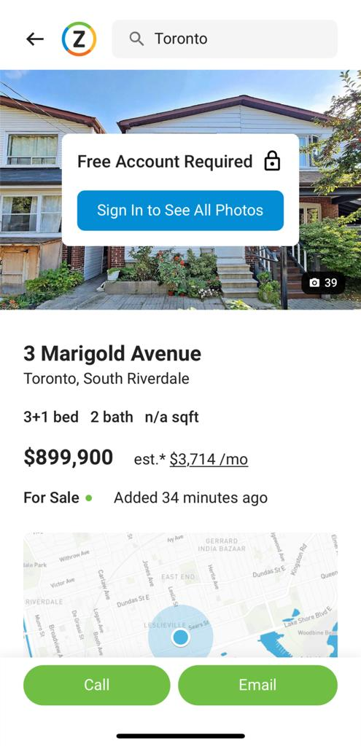

1. **Create a new Android Studio project with at least 1 activity scaffolded**

**Answer: -** Please check the GitHub account it does have the MainActivity in it.

1. **Push a copy of your application shell to the private GitHub repo with JaretWright as a collaborator. Add a README.md file that explains the your application and the technologies to be implemented. Use a proper Android Studio .gitignore file.**

**Answer: -** Done here is the [link](https://github.com/Anmolsharma786/RealEstateApp)